Chennai-602105


SIMATS ENGINEERING
Saveetha Institute of Medical and Technical Sciences
Chennai-602105

CSA0311-DATA STRUCTURES
CO1-ASSESMENT TOOL
DEBUG PROGRAM

NAME:AKILESHWARAN A
REG NO:192511354
COURSE:Data structures
COURSE CODE:CSA0311
DATE OF SUBMISSION:03/08/2026

QUESTION 1

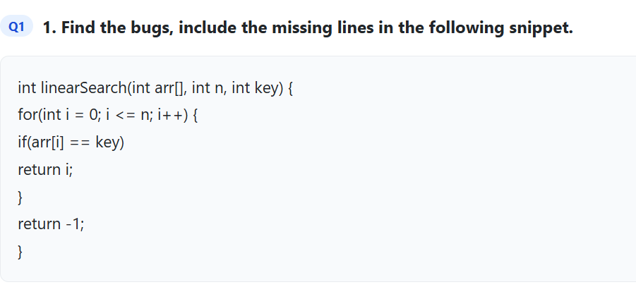

CODE

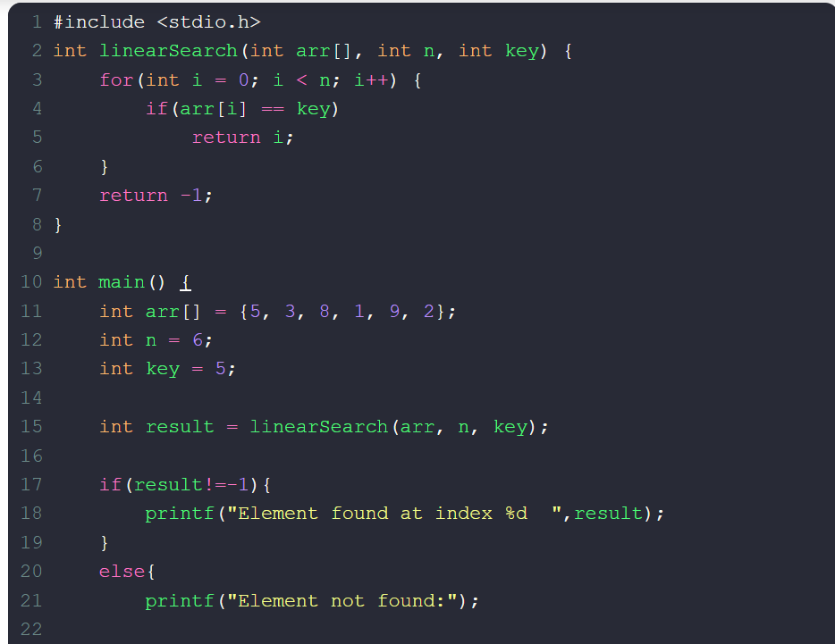

QUESTION 2
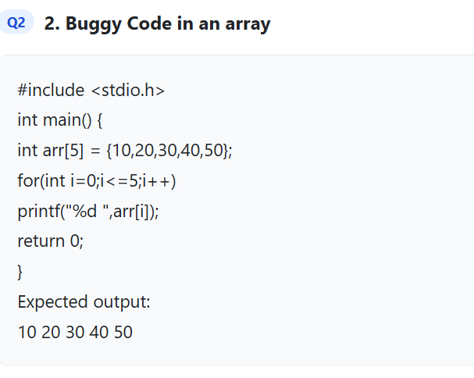
CODE
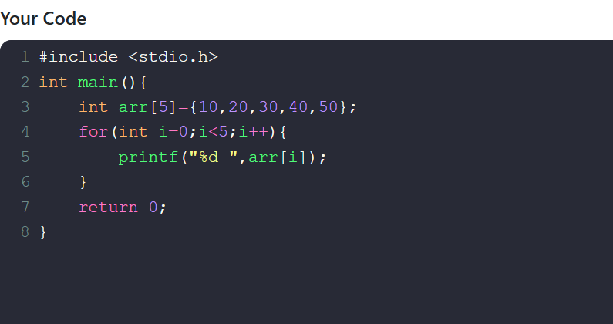

QUESTION 3
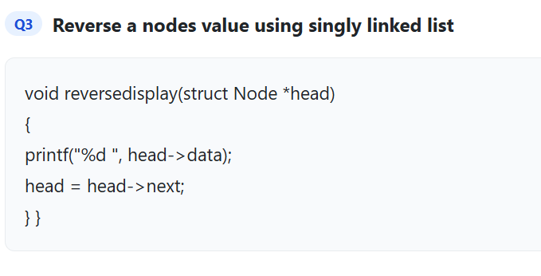
CODE
